How to log your hours for Microsoft:

- Go to https://microsoft.benevity.org/ and log in with your Microsoft credentials:

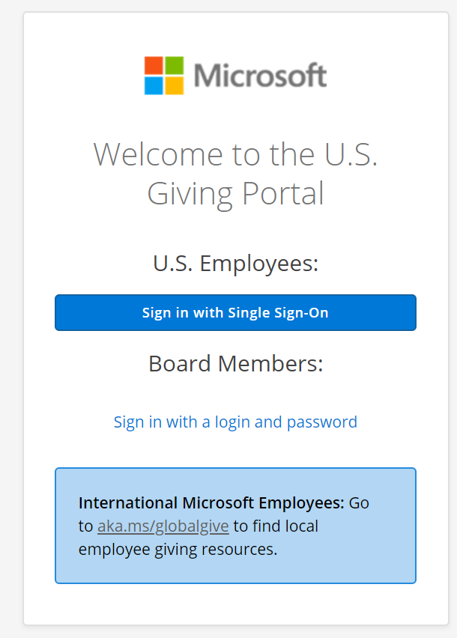

- Navigate to the top of the menu to ‘Volunteer’ and ‘Track Volunteer Time’

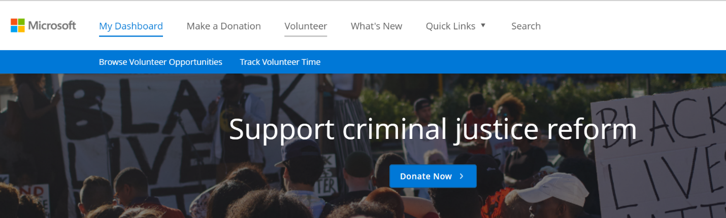

- Search for ‘Pasado’s Safe Haven’ in the search bar and click ‘Search’ and then ‘Add’:
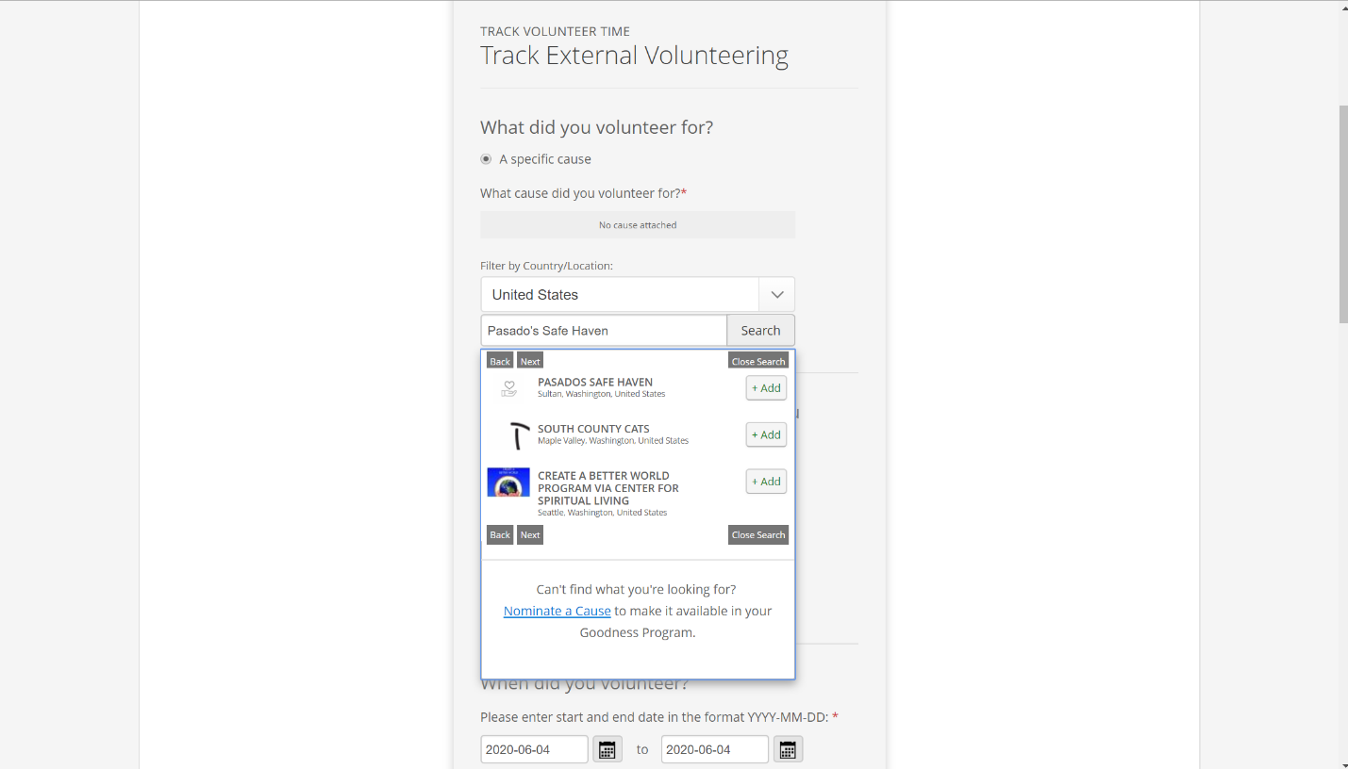

- Enter:
  - Number of hours and minutes
  - Date(s) volunteered
  - Did you use your professional skills?
  - What skill you used while volunteering
  - Volunteer Rewards: default to ‘Company Match’ (don’t change this)
  - What did you do while volunteering?
  - Comments for charity (optional)
  - Rate your volunteer experience (optional)

- Click ‘Next: Confirm Volunteer Time’ (you’re not done yet!!)

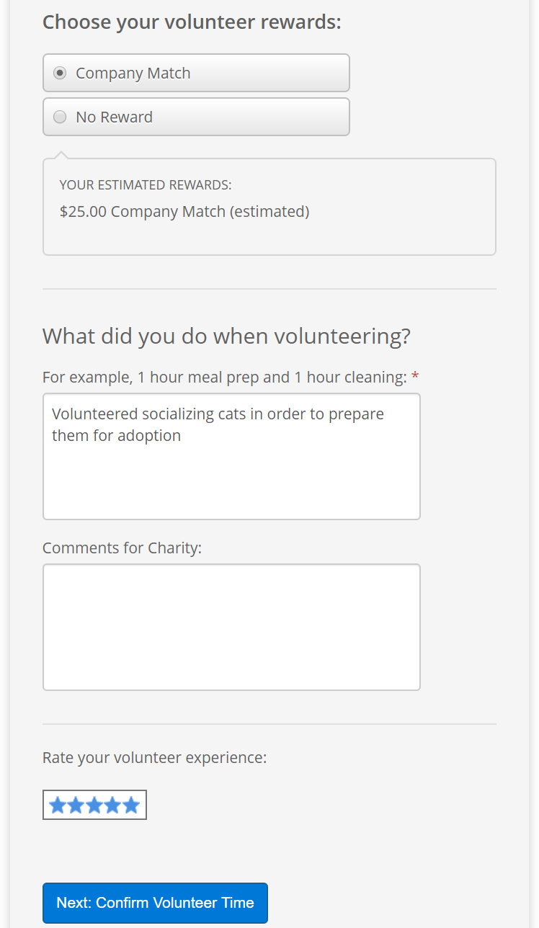

- On the next page, click ‘Submit Volunteer Time’
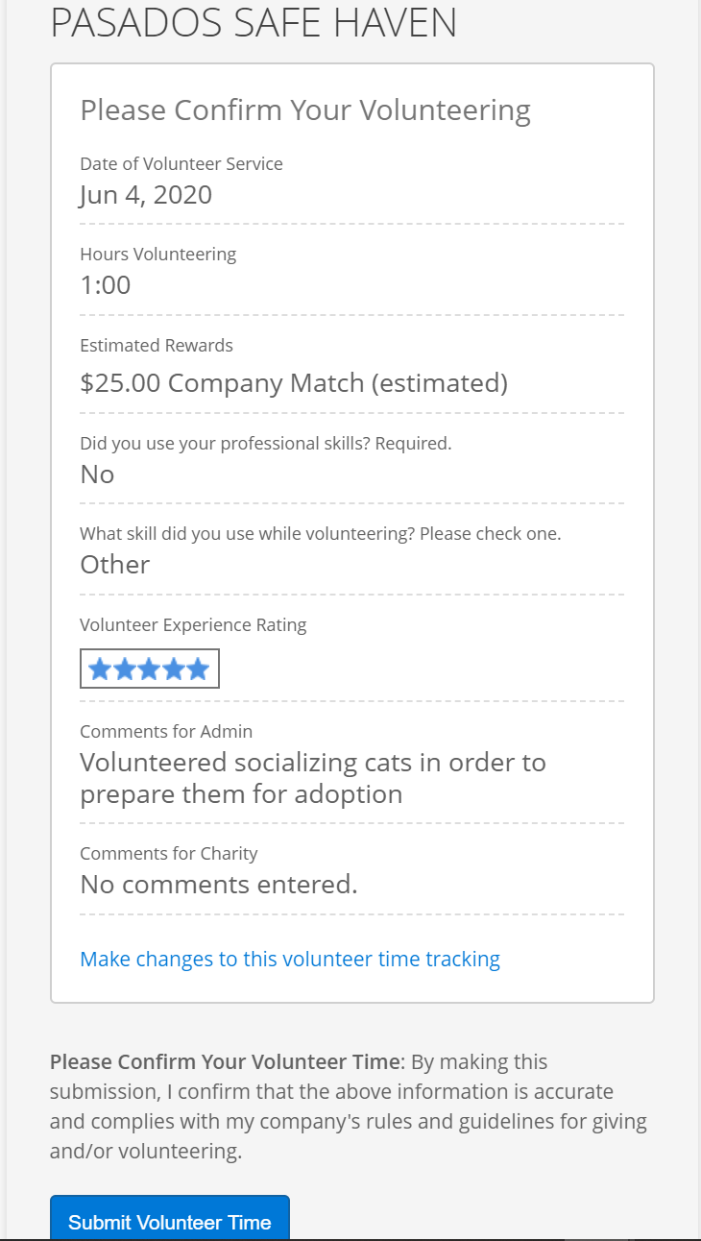

- Once you land on the confirmation page, you are done:
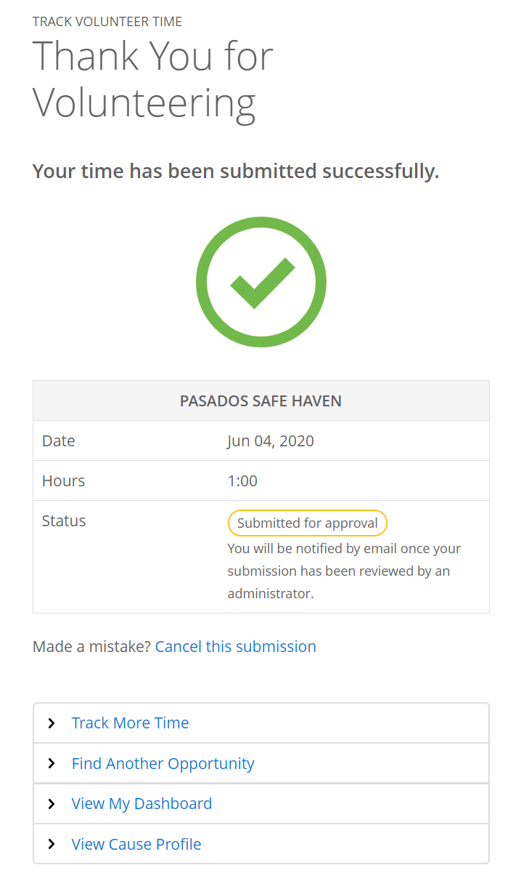
Tip: Time traveling to/from an event should not be counted in this volunteer time. If you type ‘travel’ or anything related to that in the comment box, you will receive an email from Benevity asking you to clarify what you did volunteering and reminding you that you cannot count travel time towards volunteering.

