**Ways to Enter Time**

1. From the email you receive the morning of the shift you signed up for: click on “go to check-in page”. From there, choose to either clock in with the shift time OR with a custom time OR check in now. Do the same when you are leaving the sanctuary.

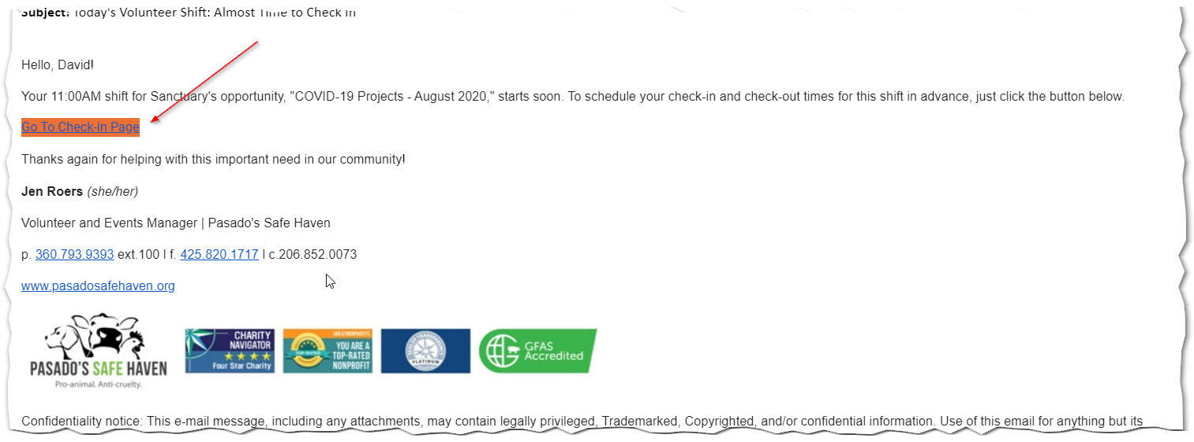

1. From “Track Hours” in the volunteer software:

